When you first enter your resits space, you will see a folder called ‘Please submit your assignment here’ in your Visual TOC.
This guide will provide guidance and checklists with screenshots for the following topics:
- How to create an assignment, including recommended assignment settings for your resit assignment folder (pp. 2 – 6)
- How to link your assignment into the Visual TOC so students can access the assignment from the folder (pp. 7 – 8)
- How to create a rubric in Brightspace (pp. 9 – 10)
- How to link your assignment to Turnitin® for similarity check or marking (pp. 11 – 13)

Please note that 1. and 2. are essential for creating your assignment and making it visible to students.
3. and 4. will only be of interest to you if you would like to use the rubrics tool in Brightspace or Turnitin®.

Setting up a resits assignment submission folder
Start by selecting ‘Assignments’ from the ‘Course Tools’ drop-down menu.
Once the assignments tool opens, select the blue ‘New Assignment’ button to create your resit assignment. This will open the assignment editor for you.

Now follow the checklist with recommended settings to finish setting up your assignment.
Assignment name and instructions
1 | Start in the ‘Properties’ tab.  Give your assignment a name (1) and provide students with instructions (2).  Note: You can use the instructions box to provide the students with all the information they need. Alternatively, you can attach instructions as a Word document or pdf as shown in the next step. |  | 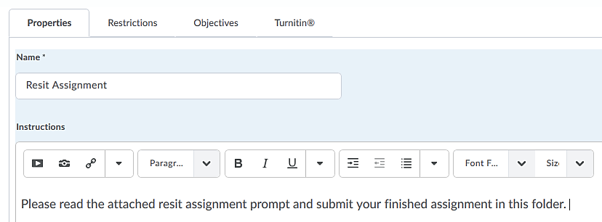  2  1 |  |  | ☐
2 | Under ‘Attachments’, you can upload a prompt in Word or pdf format by selecting file and uploading the document to Brightspace (1). Alternatively, you could choose to record instructions in audio or video format (2).  Note: This is also where you could upload any grading rubric in Word or Excel format that you might wish to use for evaluating your student’s submission. |  | 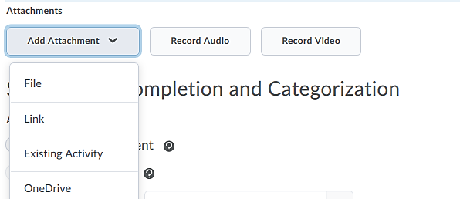  2  1 |  |  | ☐
Submission and completion settings
3 | Assignment type  Leave the default of ‘Individual assignment’ as you will want all students enrolled in the resits space to see the assignments. |  |  | ☐
4 | Submission type  If you want students to be able to upload their assignment as a file, you should also leave the default of ‘File submission’. |  |  | ☐
5 | Files Allowed per Submission  If students only need to submit one file, i.e., one word document with an essay, you could switch the setting here to ‘One File’. If students need to submit multiple files, leave the default ‘Unlimited’. |  |  | ☐
6 | Submissions  Our recommendation is that you leave the default of ‘All submissions are kept’. This means that even if a student might submit the wrong file by mistake first, he/she can go back into the folder and submit the correct file. Once you as the instructor go in, you will see a whole history of student submissions and can select the one to mark. |  |  | ☐
7 | Notifications  Enter an email address in the box below ‘Notification Email’ (1) if you would like to receive a notification each time a student makes a submission in the assignment folder.  Leave the setting under category as they are by default (‘No Category’) (2).  Note: In a regular semester, you could group your assignments into categories (i.e., essays, homework, etc.) but as you will only have one assignment folder in your resits space, there is no need to create a category. |  | 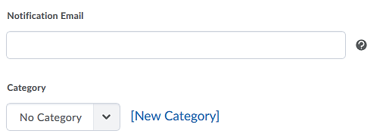  2  1 | ☐
Evaluation and feedback settings
8 |  | Score out of  Determine the maximum score for the assignment.  Note: Providing this score as part of your feedback will help students see how they did on their resits assignment. |  |  | ☐
9 |  | Grade Item  Simply leave this box at its default of ‘None’.  Note: In a regular semester, you would set up a gradebook and grade items to record your students’ progress. As you will be entering the final mark for the resit assignment directly in SITS, though, there is no need to set up a gradebook in Brightspace and attach a grade item to this resits assignment. |  |  | ☐
10 |  | Rubrics  If you would like to use a Brightspace rubric to mark your student’s assignment, this is where you could create a rubric and attach it to the assignment for marking. However, you can just as easily use a rubric you have in a Word document or Excel sheet. Simply mark your student’s submission, record your feedback and score in your Word doc or on your Excel sheet and attach it in the feedback area.  Note: Click here for a quick guide on how to create a rubric in Brightspace. |  |  | ☐
11 |  | Default Scoring Rubric  Leave the default of ‘No default selected’.  Note: In a regular semester where you might have multiple rubrics attached to one assignment, you could select a default rubric here. |  |  | ☐
12 |  | ePortfolio Artefacts  Uncheck the box next to ‘Allow users to add this folder to their ePortfolio’.  Note: This is only a minor things, but by unchecking this, you are preventing students to export the result of this resit into their ePortfolio tool. |  |  | ☐
13 |  | Anonymous Marking  Check the box next to ‘Hide student names during assessment’ if you would like to anonymise marking. |  |  | ☐
Restrictions
14 |  | When you are done configuring the settings in the ‘Properties’ tab, switch to the ‘Restrictions’ tab.  Uncheck the box next to ‘Hidden from users’. This will ensure that students will be able to see and access the assignment folder once they are enrolled on the resits space. | 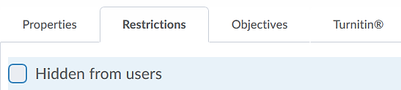 |  | ☐
15 |  | Due date  We recommend that you enter the due date for the resit assignment as August 9th so students can see it when they look at the assignment. |  |  | ☐
16 |  | Availability  If you don’t want students to see the assignment prior to a certain date and time, you might wish to enter a start date and time (1).  Normally, you could also set an end date for the assignment folder at which point students would no longer be able to access the assignment folder (2). For this resit assignment, there is not really any necessity to do this, though. | 2  1 |  | ☐
17 |  | Release conditions  For this resit assignment, you don’t have to set release conditions.  Note: In a regular semester, this is where you could set a condition of what students will have to do to access the assignment. | 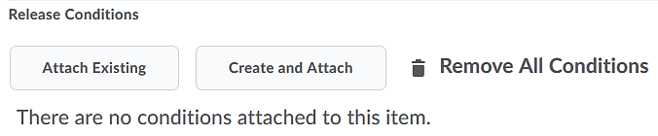 |  | ☐
18 |  | Special Access  For this resit assignment, you don’t have to worry about special access.  Note: In a regular semester, this is where you could set up special access conditions for users. Special Access comes in handy for students with specific accommodations, or if a student was off ill and couldn’t submit an assignment, for instance. |  |  | ☐
Objectives
19 |  | For this resit assignment, you don’t have to worry about the ‘Objectives’ tab.  Note: In a regular semester, this is where you could associate module/unit learning objectives with a specific assignment. |  |  | ☐
Turnitin
20 |  | If you are not using Turnitin® for similarity check or marking, you don’t have to worry about the ‘Turnitin®’ tab.  If you would like to use Turnitin® for similarity check or marking, click here. | 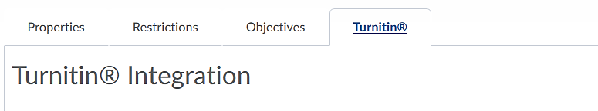 |  | ☐
Save and close
21 |  | Once you are done setting up your assignment, click on the blue ‘Save and Close’ button on the bottom of your screen.  You will now see your assignment your assignment in the assignment area of Brightspace. | 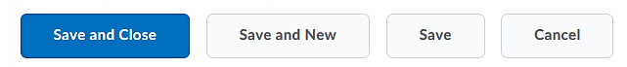  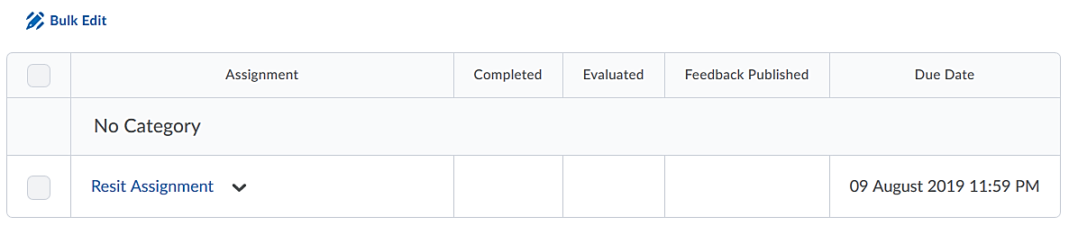 |  | ☐

Linking your resit assignment submission folder in the content area
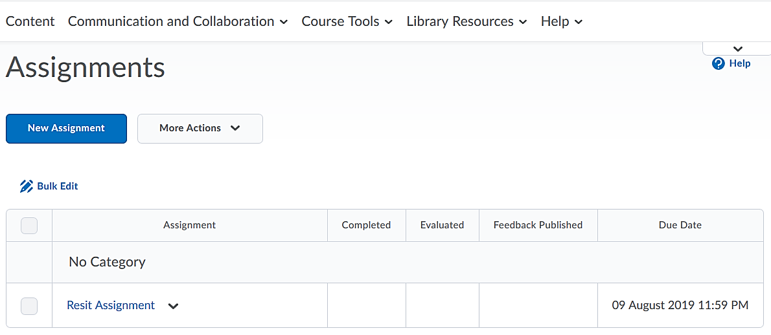
Start by navigating out of the assignments tool and into your content area.

1 | Once you are in the content folder ‘Please submit your assignment here’, click on ‘Existing Activities’ (1) and select ‘Assignments’ from the top of the list (2). | 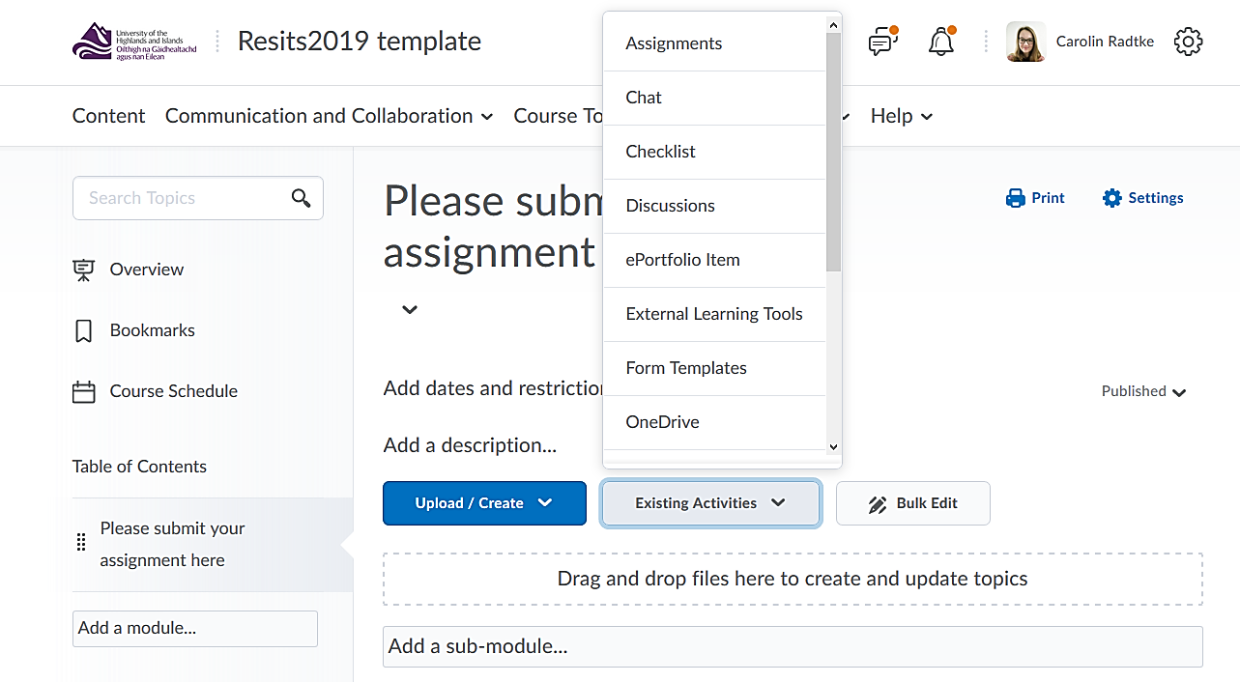  2  1 | ☐
2 | This will open a new window. To add the resit assignment you created, simply click on the assignment. | 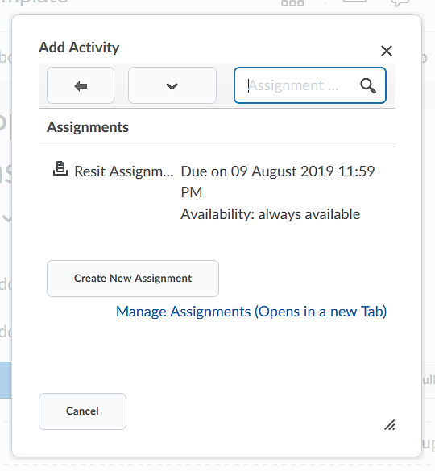 | ☐
3 | Your assignment has now been added to the table of contents and is visible for students. | 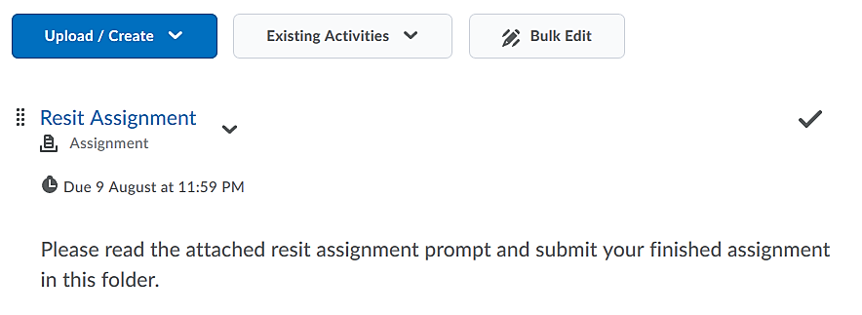 | ☐

Quick Guide – Rubrics in Brightspace
As mentioned before in the checklist for how to set up your assignment, instead of using a rubric in Brightspace, you can just as easily use a rubric you have in a Word document or Excel sheet. Simply mark your student’s submission, record your feedback and score in your Word doc or on your Excel sheet and attach it in the feedback area. This might be the way to go in particular, if you have ranges in your rubric levels which the rubric tool in Brightspace cannot easily accommodate.
If you choose to use a rubric in Brightspace, you can set up your rubric right when you customise your assignment settings. In the properties tab, simply click on the blue ‘Create Rubric in New Window’ link under ‘Rubrics’. This will open a new window with the rubrics editor for you.

1 | Once you are in the rubrics editor, give your rubric a name (1), select the type of rubric you would like to use (analytic or holistic) (2), and select the scoring method (points, percent or custom points) (3). | 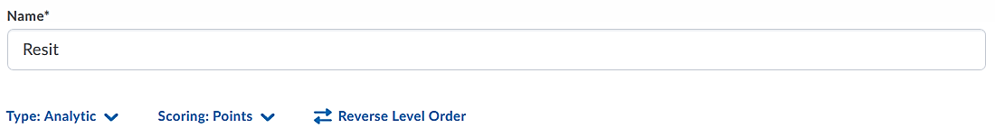  3  2  1 | ☐
2 | Enter criteria (1) and level names (2) as well as any descriptions (3). You can also add initial feedback (4) for each level/criteria combination that students will automatically see when you score their assignments using the rubric.  You can do all of this by simply clicking on any given field and entering text.  Add further criteria or levels by clicking on the plus – buttons (5 and 6 – additional levels on either side of the spectrum; 7 – additional criteria). | 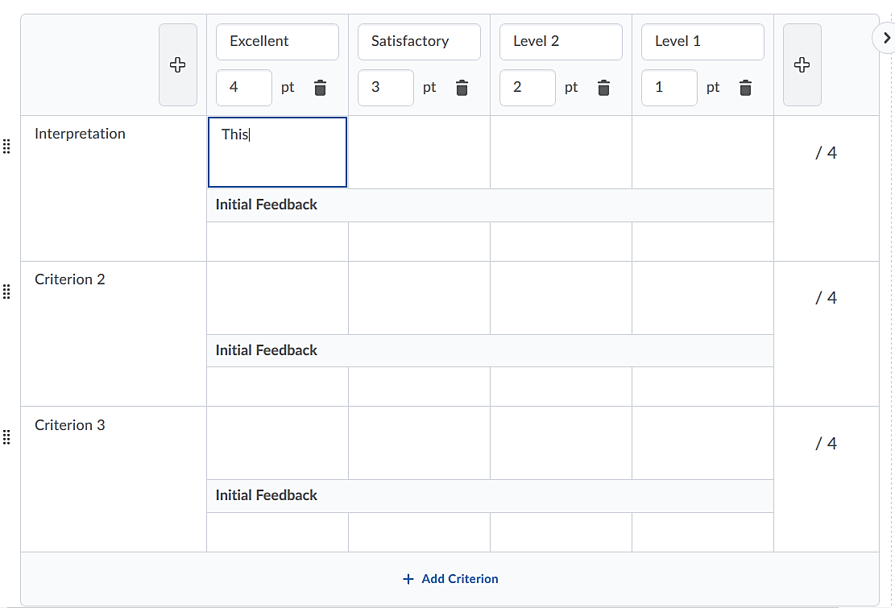  7  4  1  2  6  5  3 | ☐
3 | Overall Score  Here, you can edit the level names (1), scores (2), and descriptions (3) for the overall score of the rubric.  You can do all of this by simply clicking on any given field and entering text. | 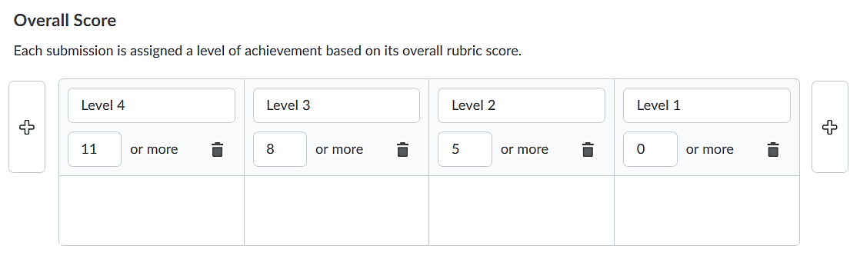  3  2  1 | ☐
4 | Before you close the rubric, make sure that the Turnitin®is set to ‘Published’ at the top right-hand side of the screen so students can see the rubric and so you can use if for marking.  When you are done editing your rubric, click the grey ‘Close’ button on the bottom of your screen. |  | ☐
5 | Navigate back to the assignment folder set up area, locate the sections on rubrics in the properties tab, and select the grey ‘Add Rubric’ button (1). This will open a new pop-up window. Select your resits rubric (2) and click on ‘Add Selected’ (3).  You will now see that the rubric has been attached to your assignment.  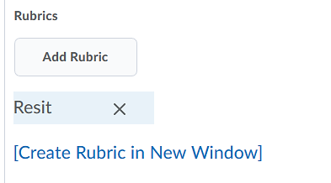 | 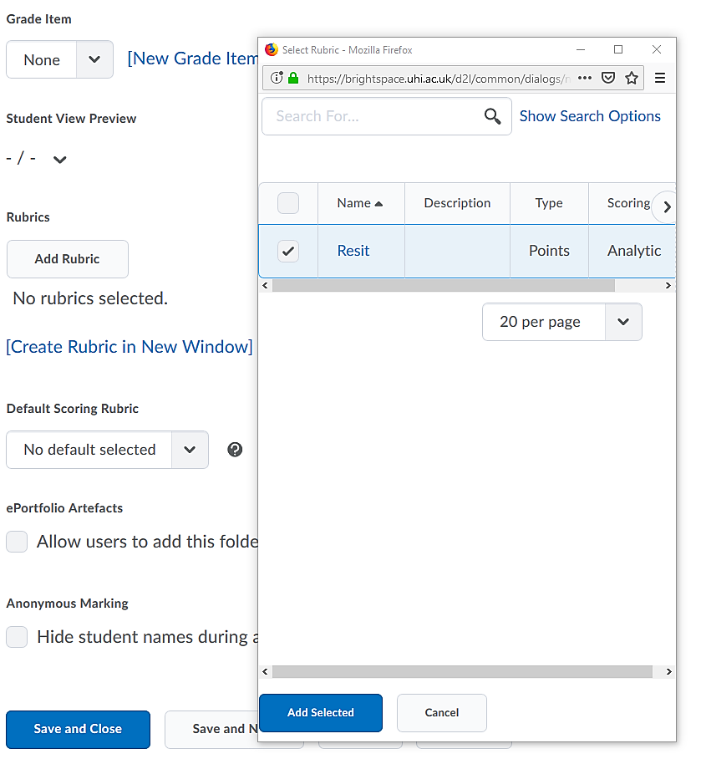  1  2  3 | ☐

Quick Guide - Turnitin® in Brightspace
Use Turnitin® Originality Check® to generate similarity reports and Turnitin® GradeMark® to mark in Turnitin®. Marking in Turnitin® will allow you to annotate student assignments and use rubrics created in Turnitin®. As mentioned before in the checklist for how to set up your assignment, instead of using a rubric in Turnitin®, you can also just as easily use a rubric you have in a Word document or Excel sheet, though. Simply mark your student’s submission, record your feedback and score in your Word doc or on your Excel sheet and attach it in the feedback area. This might be the way to go in particular, if you have ranges in your rubric levels which the Turnitin® rubrics tool cannot easily accommodate.

To set up Turnitin®, navigate to the Turnitin® tab in your assignment set-up.

1 | Check the box next to ‘Enable GradeMark® for this folder’.  This will allow you to use Turnitin® for marking as well as enable Originality Check® later on.  If you intend to mark using Turnitin®, we recommend that under ‘Transfer’, you select ‘Automatically sync grades as Draft in Brightspace’. This will mean that any grades in Turnitin® are automatically exported into Brightspace. This way you will only need to publish them to make them visible to students. |  | 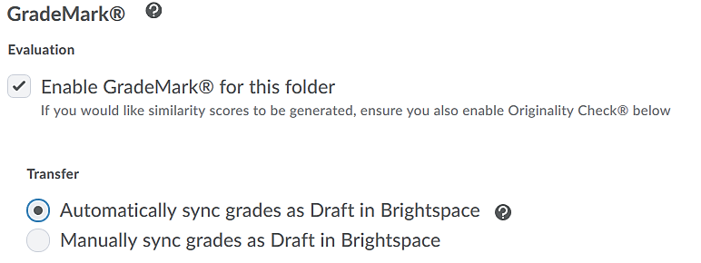 | ☐
2 | If you would like to use the Turnitin® Originality Check®, check the box next to ‘Enable Originality Check® for this folder’. |  | 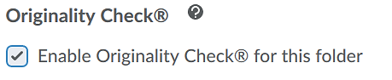 | ☐
3 | Display  Check the box next to ‘Allow learners to see Turnitin® similarity scores in their submission folders’ if you would like students to see the results of the Originality Check®. |  | 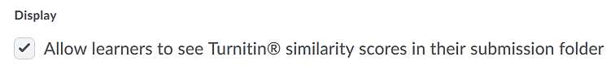 | ☐
4 | Frequency  We recommend that you leave the default of ‘Automatic originality checking on all submissions’ checked. This way all submissions made by students will be automatically checked. |  | 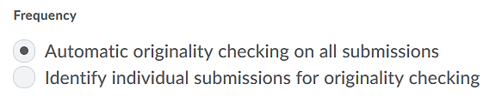 | ☐
More Options in Turnitin®
5 |  | Click on the grey ‘More Options in Turnitin®’ to attach a rubric and edit further Turnitin® settings for your submission folder.  This will open a pop-up window. | 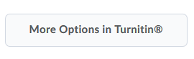 | ☐
6 |  | In the pop-up window, click on ‘Optional Settings’. | 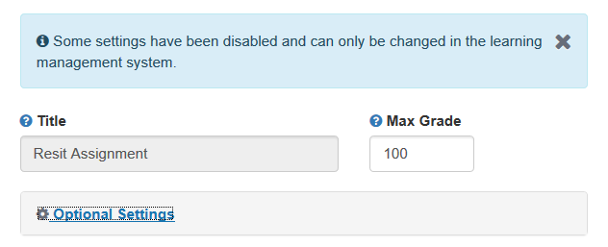 | ☐
7 |  | Submission settings  Edit your submissions settings here and either attach an existing rubric or grading form by selecting it from the list (1), or launch the Turnitin® rubric manager to create a new Turnitin® rubric or grading form (2). | 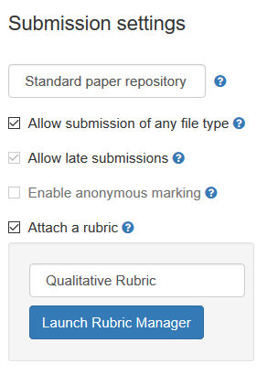  2  1 | ☐
8 |  | Compare against  Edit your settings to determine what you would like to have your student’s resit submission compared against. | 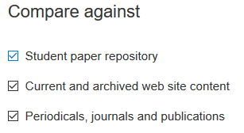 | ☐
9 |  | Similarity Report  Edit your settings to determine how the Turnitin® similarity reports will be generated. | 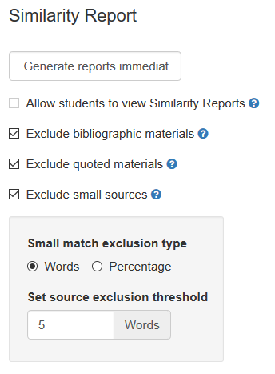 | ☐
10 |  | When you are done, click the blue ‘Submit’ button on the bottom of the page. Your Turnitin® settings have now been saved and any Turnitin® rubric you chose will be available for marking later. | 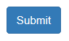 | ☐

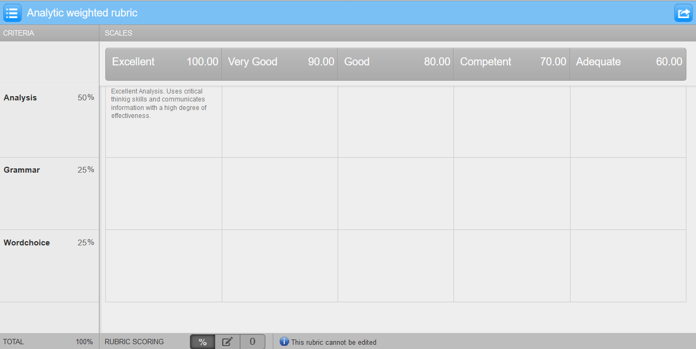
Rubrics and grading forms in Turnitin® work similarly to rubrics in Brightspace as shown above.

Simply edit criteria, levels, descriptions/feedback and scores by clicking on the corresponding fields.

