Click on the Windows start button and then All apps:
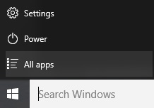
Navigate to Microsoft System Center and select Software Center:
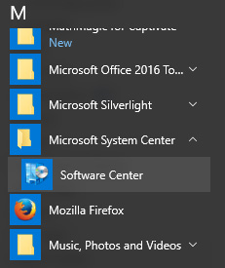
In Software Center select Camtasia Relay Recorder:
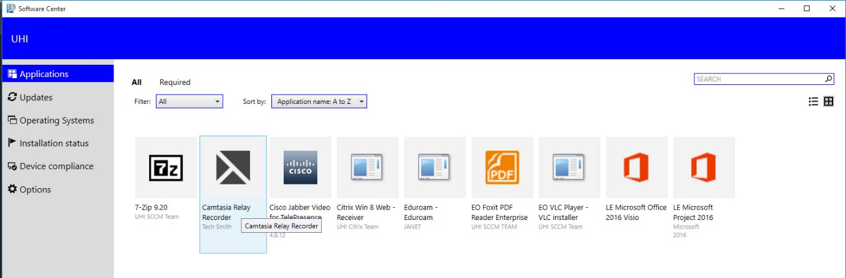

Click the install button:
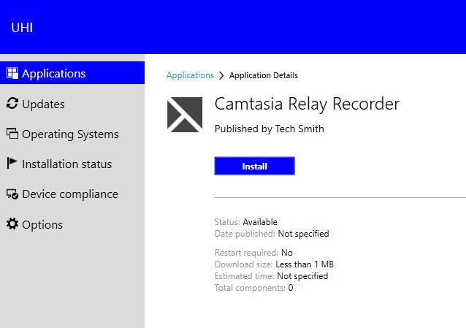
If your laptop or PC has the correct permissions, installation only takes a few seconds:
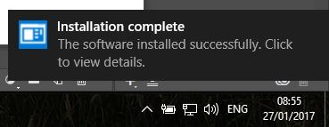
You’ll find the application listed under All apps:

