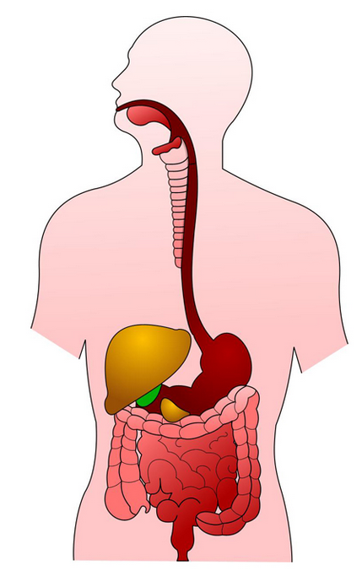

Anus

Small intestine

Pancreas

Stomach

Oesophagus

Salivary glands

Pharynx

Rectum

Large intestine

Gall bladder

Liver

Tongue

Mouth