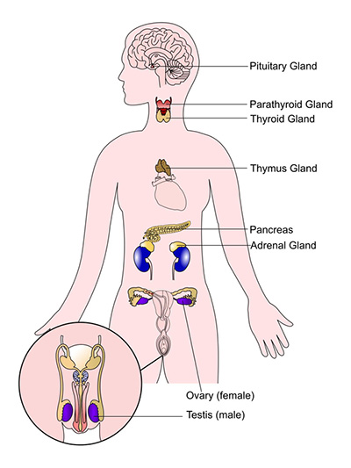

**Testis (male)**

**Ovary (female)**

**Pituitary Gland**

**Adrenal Gland**

**Pancreas**

**Thymus Gland**

**Parathyroid Gland**

**Thyroid Gland**