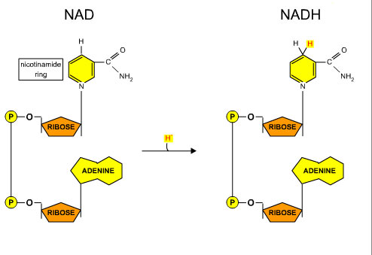

O

O

O

C

C

**H**

**H**

Adenine

H

H

Ribose

Ribose

Ribose

Ribose

Adenine

N

N

Nicotinamide ring

NADH

NAD

O

O

O

NH2

NH2