*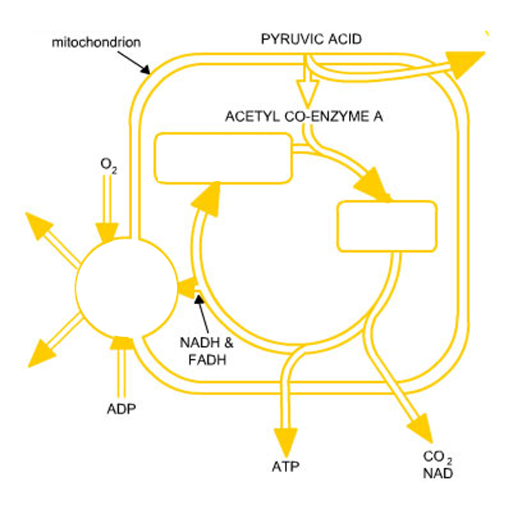*

Citric acid (6-carbon)

NADH & FADH

CO2 & NAD

ATP

ADP

O2

Oxaloacetic acid (4-carbon)

ACETYL CO-ENZYME A

PYRUVIC ACID

mitochondrion